- Russian Academy of Sciences  - Boreskov Institute of Catalysis, SB RAS  - Moscow State University  - Irkutsk Scientific Center, SB RAS  - Ministry of Education and Science of the RF  - Ministry of Industry and Trade of the RF | - Russian Foundation for Basic Research  - Consortium on SCFT  - ZAO “SCHAG”  - Journal "Supercritical Fluids: Theory and Practice”

4 – 7 July 2011
The 6th Scientific and Engineering Conference with International Participation
"Supercritical Fluids: Fundamentals, Technologies, Innovations"
Listvyanka, Baikal
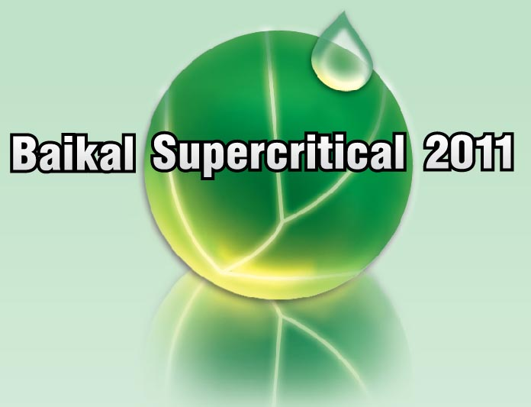

Web-site: http://conf.nsc.ru/SCF-2011

INVITATION

The 6th Scientific and Engineering Conference with International Participation “Supercritical Fluids: Fundamentals, Technologies, Innovations” is the next event in the series of SCF Conferences started in 2004 in Rostov. The SCF technologies belong to a very important and highly challenging modern field of technologies which provide the ecological purity and industrial safety protocols in full accordance with the Principles of Green Chemistry. In the nearest future, the economic impact from the application of SCF technologies could be compared to that of laser and information technologies. The previous SCF Conference clearly showed that such progress is possible due to the integration of Russian scientific and research organizations, universities, high technology enterprises, state authorities and investors. Only such integration will allow SCF technologies to meet the world standard of technological and practical application. The previous Conference demonstrated also great interest of scientific, business and administrative groups in the development of SCF technologies for economic growth and national security of the RF. The scientific SCF schools existing in Russia work at the world level and can contribute to the advancement of SCF technologies in our country.
For the first time the SCF Conference will take place in Siberia (the previous five events were held in the European part of RF). This would attract the ample and diverse scientific and technological potential and resources of the East-Russian regions to the development of SCF in Russia.

Organizers
- Boreskov Institute of Catalysis, Siberian Branch of RAS, Novosibirsk, Russia (IC SB RAS)
- M.V. Lomonosov Moscow State University (MSU)
- Irkutsk Scientific Center SB RAS, Russia
- Baikal Museum ISC SB RAS, Russia
- Journal "Supercritical Fluids: Theory and Practice”
- ZAO “SCHAG”

Program committee
V.V. Lunin, Academician of RAS (Moscow) – Chair of the Program Committee
V.N. Bagratashvilli, Prof., ILIT RAS (Troitsk) – Co-Chairman
V.M. Valyashko, Prof., IGIC RAS (Moscow) – Co-Chairman
M.A. Anisimov, Prof., University of Maryland (USA)
K.G. Bogolitsyn, Prof., North Federal University (Arkhangelsk)
N.I. Borisenko, Prof., SFU (Rostov-on-Don)
V.M. Buznik, Academician of RAS, IMET RAS (Moscow)
A.R. Vodyanik, SFU (Rostov-on-Don)
A.A. Vostrikov, Prof., IT SB RAS (Novosibirsk)
Yu.E. Gorbaty, Prof., IEM RAS (Chernogolovka)
F.M. Gumerov, Prof., KSTU (Kazan)
A.M. Egorov, Academician of RAMS, MSU (Moscow)
D.A. Lemenovskii, Prof., MSU (Moscow)
V.I. Minkin, Academician of RAS, SFU (Rostov-on-Don)
B.F. Myasoedov, Academician of RAS, IGAC RAS (Moscow)
V.N. Parmon, Academician of RAS, IC SB RAS (Novosibirsk)
M. Poliakoff, Prof., The University of Nottingham (Great Britain)
V.K. Popov, ILIT RAS (Troitsk)
I.A. Revelsky, Prof., MSU (Moscow)
M.Yu. Sinev, PhD, SICP RAS (Moscow)
A.Yu. Shadrin, Prof., Radium Institute (St. Petersburg)
A.R. Khokhlov, Academician of RAS, MSU (Moscow)

Organizing committee
Chair of the Organizing committee – V.V. Lunin, Academician of RAS (Moscow)
Co-Chair – V. I. Bukhtiyarov, Corresponding Member of RAS, IC SB RAS (Novosibirsk)
A.G. Chistyakov, Ministry of Industry and Trade of the RF (Moscow)
I.V. Bychkov, Corresponding Member of RAS, Irkutsk Scientific Center, SB RAS (Irkutsk)
Y.F. Kozlov, RUSSCIENCE (Moscow)
O.N. Martyanov, Dr. Sci. (chem.), IC SB RAS (Novosibirsk)
O.O. Parenago, PhD (chem.), IGIC RAS (Moscow)
V.A. Fialkov, PhD (geogr.), Baikal Museum, ISC SB RAS (Listvyanka)
O.T. Rusinek, Dr. Sci. (biol.), Baikal Museum, ISC SB RAS (Listvyanka)
A.A. Spiridonov, IC SB RAS (Novosibirsk)
N.S. Krylova, IC SB RAS (Novosibirsk)
V.A. Ilyina, IC SB RAS (Novosibirsk)

Secretary:
L.Ya. Startseva, IC SB RAS (Novosibirsk)
S.Z. Vatsadze, Dr. Sci. (chem.), MSU (Moscow)

SCOPE
  - thermodynamics and phase equilibria, transfer phenomena, microstructure of homogeneous
and heterogeneous SCF systems;
  - chemical synthesis and reactions of SC reactants and in SC media;
  - SCF and Green Chemistry;
  - SCF for energetics;
  - SCF for pharmaceutics;
  - synthesis, modification and dispersion of natural and synthetic materials;
  - extraction and fractionation;
  - analytical applications of SCF;
  - laboratory, pilot and industrial SCF systems

Conference program
The Conference program includes:
  - plenary lectures (40 minutes);
  - invited reports (25 minutes);
  - oral communications (15 minutes);
  - poster session;
  - exhibitions of equipment and brand-name products,
  - presentations of commercial enterprises;
  - round tables: education in SCFT field; equipment for SCFT research and industrial applications

Official language of the Conference is Russian. Simultaneous translation to English for foreign participants is planned.

Within the Conference, the School for young researchers and scientists is to be held.

Abstracts
Abstracts of all presentations will be published on CD and distributed among the participants at a registration desk before the Conference opening.

ABSTRACT PREPARATION
Abstract should fit no more than two pages of size A4, portrait orientation. MS Word for Windows should be used. All margins 25 mm, font Times New Roman 12 pt, 1.5 line spacing. First line(s): TITLE (CAPITALS, CENTERED, BOLD), then AUTHORS (CAPITALS, CENTERED), then Affiliations and E-mail of the presenting author (italic, centered). Superscript numbers (1, 2, 3, etc.) can be used to identify the authors’ affiliations if they are from different organizations. Name of the presenting author should be underlined. The deadline for Abstract submission is January 30th, 2011. The Abstracts should be mailed to star@catalysis.ru .
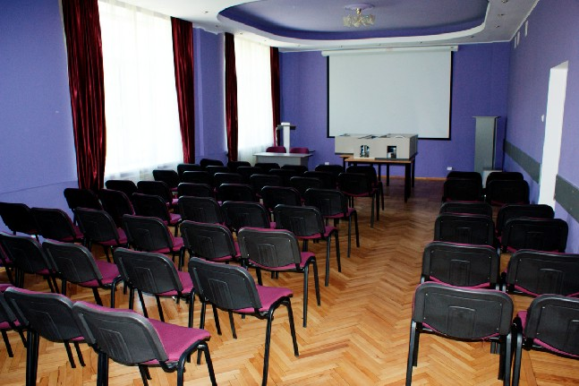
VENUE
The Conference will take place in the Conference Hall of the Baikal Museum ISC SB RAS, which is situated on the Lake Baikal coast in Listvyanka near the Angara river headstream (1, str. Akademicheskaya).

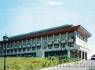
ACCOMODATION
From 03 to 09 July 2011, one- and two-bed rooms are booked in the Hotel “Baikal”.*** The Hotel “Baikal” (13, Akademicheskaya str., Listvyanka) is located in one of the most beautiful Baikal areas near the beginning of the Angara river. The place is 70 km far from Irkutsk and one hour driving from airport. All the rooms are equipped with phone, TV, and washing room with a bath. The accommodation fees (breakfast included): one-bed room – 2300-3250 rubles, two-bed room – 2500-3600 rubles, luxury room – 4400 rubles (all prices for year 2010). The Baikal Museum of SB RAS, where the Conference will take place, is a 5 minute walk from the hotel.

MEAL
Lunches will be arranged in the hotel’s restaurant; coffee-breaks, in the Baikal Museum.

REGISTRATION FEES
The registration fee for participants from academia and universities is 6700 rubles including VAT 18%. Students and aspirants fee is 3700 rubles including VAT 18%. Industrial participants fee is 9500 rubles including VAT 18%.
The registration fee covers issuing of the Abstract book, publication of information materials, participant bag, room and technique rents, auto vehicle rents (meeting of participants in Irkutsk), coffee-breaks, welcome mixer, 4 lunches, visa invitation, and excursion to the Baikal museum.

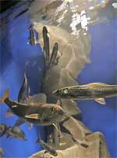
SOCIAL PROGRAM
Excursion to the Baikal Museum ISC SB RAS. The Museum has 7 big aquariums showing the real underwater world of Lake Baikal. The visitors will see omuls, graylings, breams, sturgeons, cat fishes, pikes and two seals. There is an opportunity to look at the underwater life using the interactive “bathyscaphe”. The arboretum has a unique collection of rare plants.
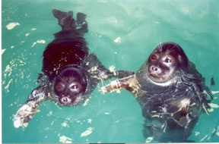
Additional excursions. A show of trained Baikal seals (Nerpa)
at the Nerpinarium in Listvyanka.
The Tal’tsy Museum of Architecture and Ethnography – a unique place with rarities of the history and culture of the East Siberia people.

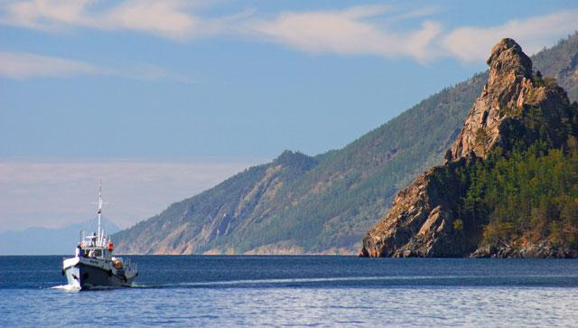
Post-tour “Bol’shie Koty”, July the 8th
Boat excursion over Lake Baikal, visiting places Bol’shie Koty and Sennaya Pyad’.
The fisherman dinner. Visiting the Museum of Baikal at Bol’shie Koty.
The details and cost will be presented in the Second Circular.

KEY DATES AND DEADLINES
30.01.2011 | Registration and submission of Abstracts
25.03.2011 | Information about accepted reports; Second Circular
15.05.2011 | Preliminary scientific program available at the Conference site
03.07.2011 | Arrival
04-07.2011 | Conference work-days
08.07.2011 | Post-tour
09.07.2011 | Departure

REGISTRATION
The Internet site for the registration http://conf.nsc.ru/SCF-2011; deadline January 30th 2011.
The Abstracts should be sent to star@catalysis.ru no later than January 30th 2011.

The Registration Form (also possible to fill in at http://conf.nsc.ru/SCF-2011 )
Name, Surname | Authors
Position, Scientific Degree | Title of communication
Affiliation | Preferable type of communication: oral (15 min), poster,  without report
Postal address | Accommodation: one-bed room, two-bed room, not needed
Phone (city code), Fax (city code) | Accompanying persons
E-mail | Post-tour

All questions should be addressed to:

In Novosibirsk in Moscow

Lyudmila Ya. Startseva Sergey Z. Vatsadze
Boreskov Institute of Catalysis SB RAS  Pr. Lavrentieva 5  630090, Novosibirsk, Russia  Phone/Fax: +7 (383) 330 62 97  E-mail: star@catalysis.ru | M.V. Lomonosov Moscow State University  Chemistry Department  119991, Moscow, Russia  Phone: +7 (495) 939 40 20  E-mail: szv@org.chem.msu.ru

